Google Drive/File Basics
Getting to Drive:
You must be signed in to Google in order to access your Drive. If signed in, you can get to Drive in the following ways: by clicking on the Apps icon in the upper left corner or the upper right corner of your screen, by selecting the Google Drive icon on the bookmarks bar (if you’ve added one), or by typing “Google Drive” in the Google omnibox.
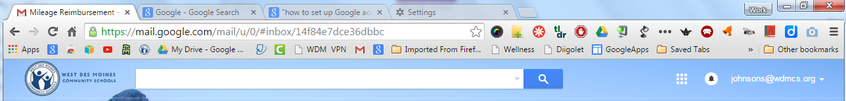

Google Drive: left screen options:
- New: Click on this to create a new Google file (Doc, Slide, Spreadsheet, Form, etc.).
- My Drive: My Drive is lot like the H drive, but accessible from anywhere via the web. Drive contains the files you have created or chosen to store on Drive.
- Shared with Me: Files/folders others have chosen to share with you. Sometimes you will get an email indicating someone has shared files; sometimes they will just appear in SHARED WITH ME without notice.
- Recent: Clicking on RECENT brings up the most recent files you have opened. This is often the quickest way to find that file you were working on yesterday.
- Starred: Files you have marked as important. Clicking on STARRED will bring up only the starred files.
- Trash: Items you have trashed will remain in trash until you choose to permanently delete them.
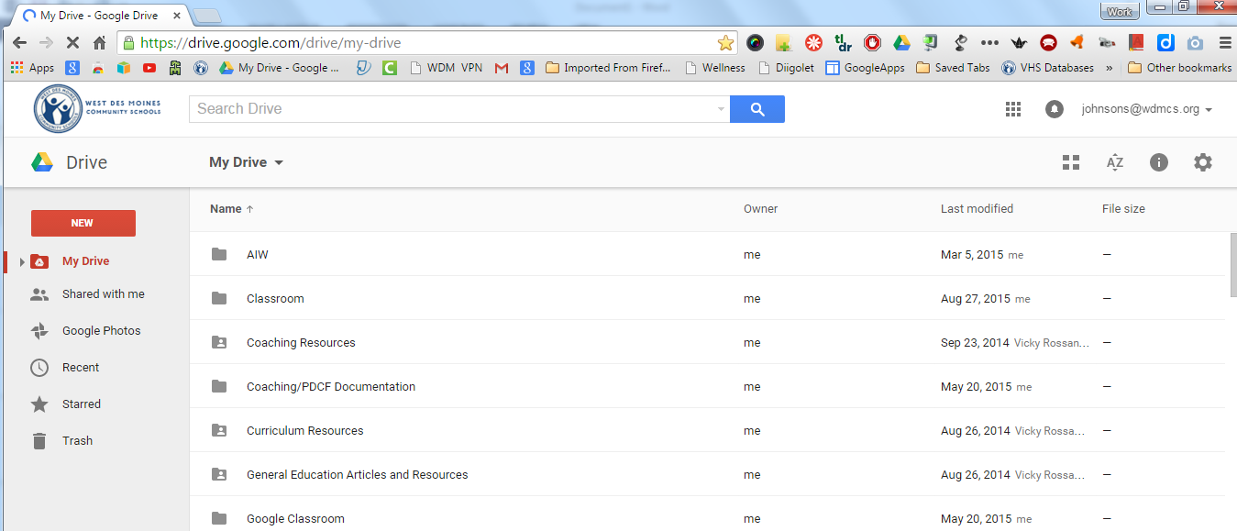
Shared Folders: The person in the icon indicates a folder shared with others (or a shared folder you have chosen to move to your drive).
View Options: You may view Drive contents in a list or grid view. List view allows you to see more files at one time.
Sort Options: Organize files by name, last modified, last modified by me, or last opened by me.

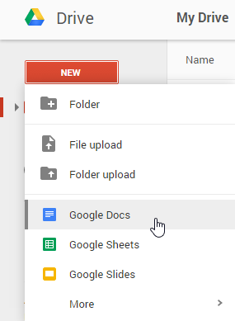
Creating a Google File:
- Select the red NEW button on the left side of Drive.
- Choose the appropriate file you need to create (doc, spreadsheet, slide, etc.). NEW also allows you to create a new folder on your drive, upload a file (Word, PPT, PDF) for storage on Google Drive, and upload an entire folder (perhaps an H drive folder you want access to on Drive).
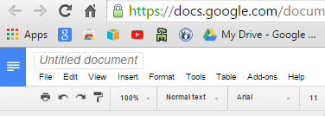
- Once you have created a document, rename it. Highlight UNTITLED DOCUMENT and then rename the document. Renaming works the same way whether you are using Docs, Slides, or other tools.
NOTE:
There is no SAVE option in Google products. Google automatically saves files as you work on them.

Docs=Word; Slides=PowerPoint; Sheets=Excel
Whether Google Docs, Slides, or Sheets, the programs function similarly to the corresponding Microsoft products, but you will notice fewer advanced options in the Google products. Items in the toolbar are also similar to the Microsoft features.

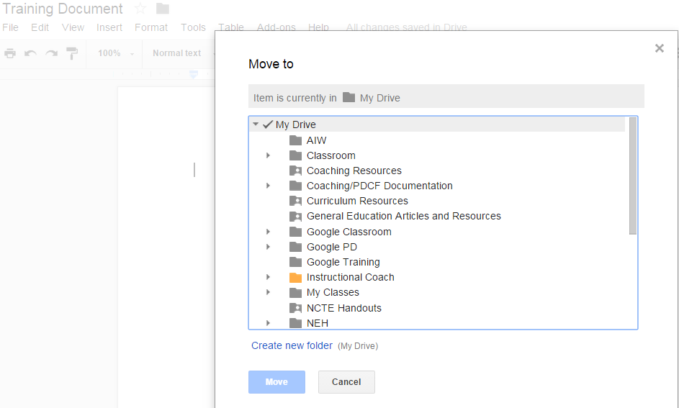
Moving a file to a folder:
- Click on the gray folder next to the title of the file.
- You may choose to move the document to an existing folder or you may create a new folder. To create a new folder, select CREATE A NEW FOLDER and name the folder.
- To move a file to an existing folder, select the destination folder.
- Click on MOVE.

Organizing Drive:
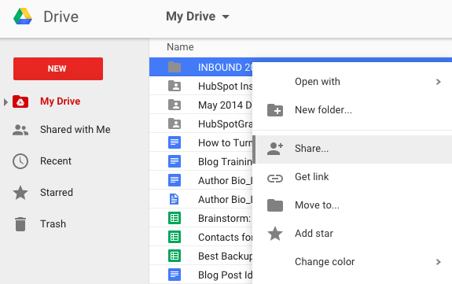
- Drive files will be easier to find if kept more organized through the use of folders. You can move items to folders using the method described earlier or by dragging files to the appropriate folders in Drive.
- You can also create subfolders within folders. Right click on the main folder, select NEW FOLDER, and name the new folder.
- Right clicking on a folder will also give you the option to change the folder’s color. This adds another level of organization to Drive.

Sharing a Google File: Google gives you the option to share files in your drive with other Google users. When you share a file, you decide what kind of rights others will have with the shared file. There are three basic rights levels for any Google file:
- Can Edit: Others who have access to the file are allowed to make changes to your original file.
- Can Comment: Others can view the file and make comments, but they cannot make any changes to the original file.
- Can View: Others can view the file, but they cannot make any changes nor can they make comments.

- Select the blue SHARE button in the upper right corner of the file.
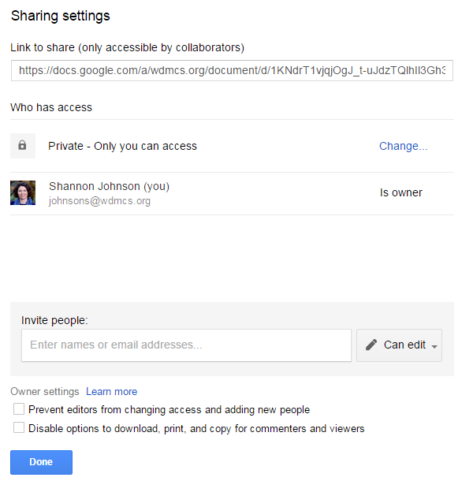
- To get a better view of sharing options, select ADVANCED in the lower right corner of the popup box.
- You are the owner of any file you create. You can choose to share the file by sharing a link or by selecting specific people with whom to share the file.
- To share with specific people, enter their name(s) in the Invite People box. Email addresses will automatically pop up as you enter names.
- Select the appropriate sharing option: edit, comment, or view.
- Owner settings: This allows you to control the file. By selecting the appropriate boxes, you can prevent others from changing the access settings as well as prevent others from copying, printing, or downloading a file.
- Once you enter names, you will also be given the option to “Notify by Email.” Alerting people by email is the best way to notify others; otherwise they may not be aware of the shared file.
- Files are initially labeled as private until you choose to change that. To do so, select CHANGE, just to the right of “Private: Only you can access.”
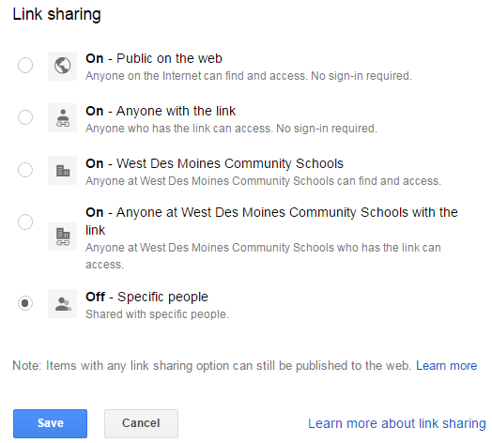
Link Sharing
You may also choose to share a Google file by sharing a link. After you click on CHANGE in step 8, you will open a box that gives you further options. The options for link sharing are listed to the right. The options allow you to decide how public you want a file to be—open to anyone, open to anyone with a link, open to only WDMCS users, or open to only a chosen group of people.

Once you select the option you want, select SAVE.

Collaborating on Google Files:
One of the major advantages of using Google Docs, Sheets, and Slides (as well as some other products) is the ability to have multiple people working on a shared file at the same time. This option is in play once you’ve shared a file—no additional step needed. Icons in the upper right hand corner of the file will indicate whether other people also have a file open at any given time.
Icons/photos indicate others who currently have a file open.
Different colored cursors indicate where others are working in the file.

