Google Account Basics

Sign-in:
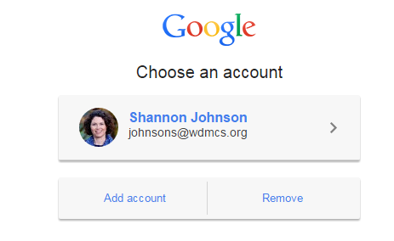
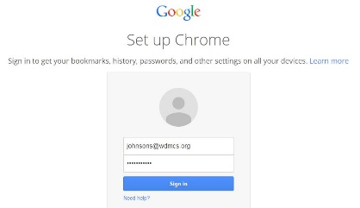
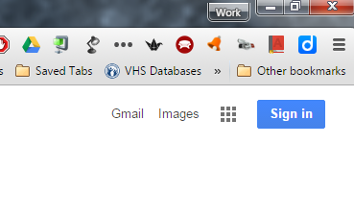
- Go to Google.com. Depending on the computer, you may get any of the following screens. All basically ask the same thing. Sign in using your district email address and password. If yours looks like the last photo, click on the arrow next to your account name to go on to step 2.

- You will be directed to your WDMCS sign-in. Enter your district username and password. You will then get the basic Google screen showing you are signed in to Google.
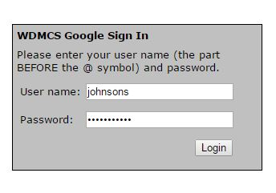
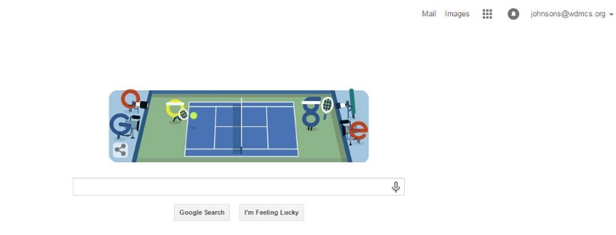

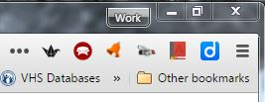
Customizing Google
By clicking on the icon that looks like three parallel lines in the upper right corner of your screen, you can customize a variety of Google details.

- Settings
  - Click on the triple line icon and then click on settings near the bottom of the dropdown menu.
  - Options you may want to select include the following:
    - Appearance: Check “Always show the bookmarks bar” and “Show Home button.” The “Get Themes” button will allow you to customize the look of your screen beyond the basic white.
    - Search: Check to see that Google is your default search engine.
    - People: You may add other accounts if you have a personal Gmail. This allows you to easily switch back and forth between the two for your convenience.
    - Advanced Settings: This will open a few more options such as adjusting the privacy settings, font size, and zoom options.

- Bookmarks
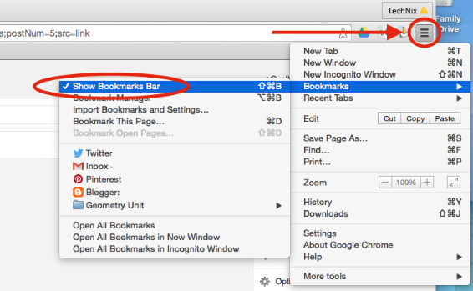
- Select Bookmarks from the triple line icon dropdown menu and then select “Show Bookmarks Bar.” This will allow you to create several onscreen shortcuts to websites you frequently use.

- To create a Bookmark shortcut, go to a frequently used website (Gmail, Google Calendar, Google Drive, etc).

- Highlight the entire URL in the omnibox, drag the highlight to the bookmarks bar, and release it. An icon with a brief description of the site should automatically appear.
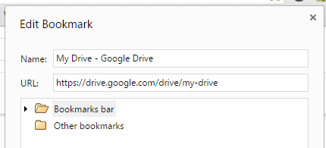
- To edit the shortcut, right click on the icon in your bookmarks bar and select “edit.” Under Name, you can choose to give it a shorter name or delete the name completely so only the icon appears on your bookmarks bar.

- Other Menu options
The triple line icon also gives you quick access to options like saving a page, adjusting the zoom of the screen, printing, clearing your history, and other items. Any customization of Google Chrome happens through this icon.

