Gmail Basics

Sign-in
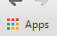
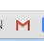
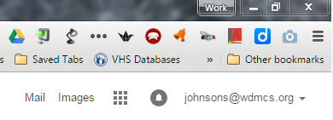
- If you are already signed in to Google, you will not need to sign in again to access your mail. You can get to Gmail by typing “Gmail” in the omnibox, clicking on the Apps icon (upper left screen) and then choosing the Gmail icon, selecting the icon on your bookmarks bar (if you have created one), or clicking on “Mail” from your Google page.
- If you have not signed in, that is your first step.

Gmail Gear Icon:
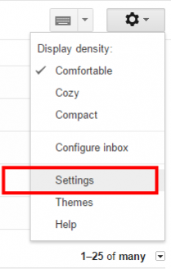
- Display Density: You can control how messages appear on your screen. Compact will show more messages at once while Comfortable will give you more whitespace.
- Themes: You change the look of your Gmail (Do you like white or would you rather have a color or photos behind your inbox?). Adjust as you wish.
- Settings: Most of the changes you need to make will be found here.

Settings/General Tab: Most of these settings are a matter of personal preference. For any changes you make, be sure to select SAVE CHANGES (scroll to the bottom of settings). Here are some you may wish to adjust:
- Conversation View: ON keeps message with the same subject line grouped together in your inbox. “Off” shows each message individually.
- Stars: Gives you options to code message in your inbox.
- Desktop Notifications: ON allows a pop window to appear when you receive a new message.
- Change picture: Add one if you wish.
- Signature: Create a signature with your name, position, and contact information.
- Snippets: SHOW SNIPPETS shows a brief preview of the message in your inbox.

Settings/Labels Tab: Outlook allowed you to organize messages into folders. Gmail uses labels instead, but they basically function the same way. The LABELS TAB allows you to customize what appears to the left of your inbox in Gmail. At the very least, make sure the following labels are marked SHOW rather than HIDE. SHOW will appear in black font if set correctly.
- Starred
- Sent Mail
- Drafts
- Spam
- Trash

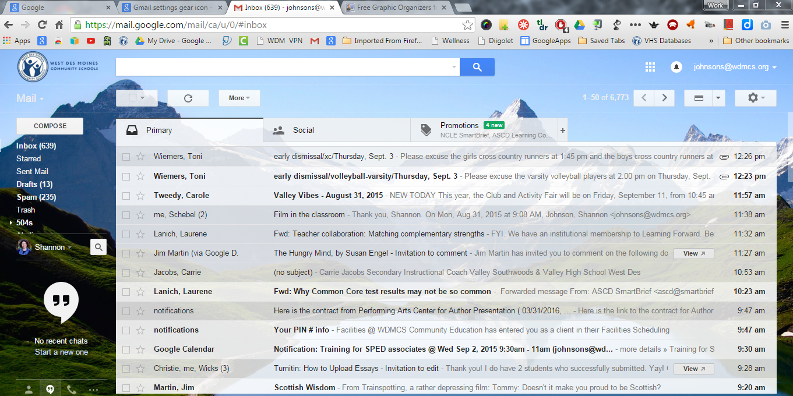
Inbox Overview:
Compose: Allows you to write a new email.
Refreshes your email to show recent messages.
Allows you to adjust your viewing options if you wish to see the current message and your inbox.
Gmail Labels: the equivalent of Outlook’s folders. You can scroll down to see additional labels.
Accesses older messages in your Inbox.
Allows you to code messages. Keep clicking on the star to get the desired code (if you selected more than one in “Settings”).
Search messages by name, subject, or keyword.

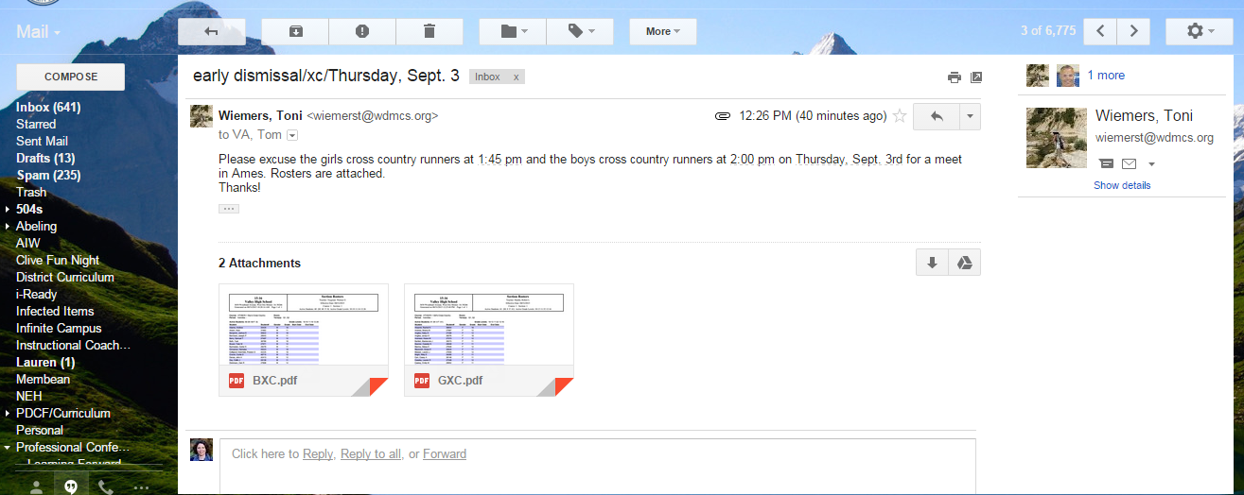
Message Basics:
Return to where you left off in Inbox
Archive message
Trash message
Move message to folder
Label message
(Similar to folder)
Opens up more options: reply all, forward, print, mark as spam, etc.
Download options: Download all attachments or save to Google Drive
Individual download options: Scrolling over the file will allow you to download the attachment or save to Google Drive.

Important differences from Outlook:
- Archived Messages: These messages are still in your Gmail until you delete them, but no longer appear in your inbox.
- Trash: All trashed messages are permanently deleted after 30 days. This is different from Outlook. If you want to keep an email, move it to a folder/label or archive it instead.

